**2025 Sweet Pickins AppleJack Craft, Vendor & Maker Market**

Event Location: Lourdes Central Catholic School, 412 Second Avenue, Nebraska City NE 68410

(end of main street- downtown Nebraska City)

Event date & time:

10:00 a.m.-4:00 p.m. Saturday September 27, 2025

10:00 a.m. – 4:00 p.m. Sunday, September 28, 2025

Set up will take place Saturday from 7:00 a.m. -10:00 a.m. Booths/Items need removed from your space promptly at 4:00 p.m. on Sunday. Indoor booths/items can be left overnight on Saturday at your own risk, as the building will be locked after fair hours. There is no supervision or security for outdoor booths.

Booth space cost & details: Booth fee is $125 for a 10’ x 10’ indoor, air-conditioned spot. We also have 16’x16’ outdoor spots. Booth rental does not include tables or chairs. Vendors are responsible for bringing their own tables and chairs. 6’ table & chair are available for rent, $25 for a table + 1 chair. We have a limited number available.

We have a select number of spots with electricity; electricity is $20 extra if requested. Please be sure to bring an extension cords and power strips you may need.

**Vendor Registration Form**

Name ______________________________________________________________________________

Business Name _______________________________________________________________________

Street Address, City, State Zip ___________________________________________________________

Phone Number (required) ___________________________________

Email (required) ___________________________________________

**We will be accepting only one vendor per consultant business (i.e. 1 Pampered Chef, MaryKay, etc.)**

**Vendor Details**  
Briefly describe the products or crafts you sell (so we can be sure to space similar vendors apart):

Any special requests or additional information we should know:

Indoor Booth Rental ($125/ea) _______ Outdoor Booth Rental ($125/ea) _____

Electricity ($20) _____ Table & chair rental ($25) ______

Total: ____________

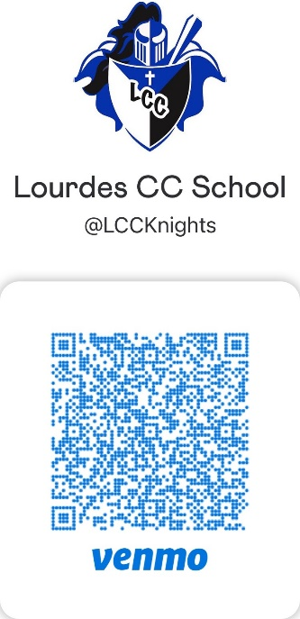Venmo payment or check payment are accepted. Please make check payable to Lourdes Central Catholic School and mailed with registration. If paying by Venmo note “AppleJack Fair”.

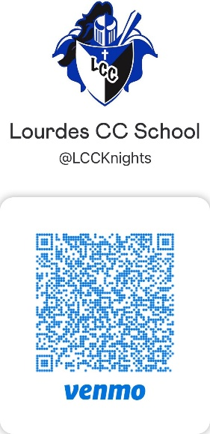If another vendor of the same business is already registered or spots are full; your check will be voided & shredded/ your Venmo payment will be returned. Payment due upon acceptance as a vendor and vendor spot only held once payment is received. All registrations and all payments September 14, 2025 to reserve your spot.

Please return your completed agreement c/o Kay DeFreece, Lourdes Central Catholic School, 412 Second Avenue, Nebraska City, NE 68410 or [specialeventsLCC@gmail.com](mailto:specialeventsLCC@gmail.com)

**Please read the following terms and conditions entirely and return with your vendor registration form!**

Once a registration is accepted, no refunds of registration fees will be allowed. This event will be held regardless of weather conditions.

We have a very large parking lot and a drop off/delivery area. Volunteers will greet you and show you to your booth. Please use the load/unload zone to bring items in and then park in the reserved vendor parking spaces. We will work to have student volunteers available to help bring items in, but please come prepared to bring in your own items/set up your booth.

No smoking. No pets.

We also ask vendors, makers, crafters to consider donating an item to our Lourdes Event fundraiser gala & auction which is held in March 2026. If you donate something, you will be noted as a donor and your item will be beautifully displayed as part of our silent auction. A volunteer will collect donations-please feel free to include a business card, catalog, etc. This is our school’s major annual fundraiser event and we appreciate your support!

**Event Coordinator Contact: Kay DeFreece,** [**specialeventsLCC@gmail.com**](mailto:specialeventsLCC@gmail.com) **or 402-873-6154**

I understand submission of a registration form does not guarantee a booth space and I will be notified of application acceptance. I understand the event will be held Saturday, September 27, 2025 and Sunday, September 28, 2025 from 10:00 a.m.-4:00 p.m. I understand the coordinators and Lourdes Central Catholic School are not responsible for any loss or damage of vendor property/goods or personal injury. I understand all registration fees are non-refundable. Upon registration form approval, a confirmation email will be sent to confirm booth rental and accept payment. Any registration forms not approved will be destroyed and checks will be voided and shredded. The event coordinators reserve the right to alter run time as necessary to best preserve/promote the event. My signature below acknowledges that I have read and agree to the terms and conditions.

Name: _____________________________________________________

Signature:____________________________________________________ Date: ________________